**GROUP 12 PYTHON ADVANCED PROJECT – A PASSWORD VAULT**

|  |  |
| --- | --- |
| GROUP MEMBERS | ROLES |
| Chorio-Philip Riyeh | Leader and Coordinator |
| Mathias Aboh Job | Docs/Presenter |
| Zainab Musa | Developer |
| Ayeoyenikan Oluwatimileyin | Docs/Presenter |
| Francis Chidiebele Dibigbo | Docs/Presenter |
| Abdulrahman Yahaya | Docs/Presenter |
| Khalil Abubakar Mustapha | Developer |
| Paul Soja | Tester |
| Jatto Favour Ogeneomamuzo | Tester |
| Adamu Murtala | Docs/Presenter |

SHORT DESCRIPTION OF THE APPLICATION

The Password Vault is a locally encrypted password manager with a master password, add/get/list entries, and a copy-to-clipboard feature.

KEY FEATURES

* Secure storage and Retrieval of entries using authenticated encryption
* Denial of access if the wrong master password is provided.
* A Password Generator

LIBRARIES USED

* os
* pytest
* sqlite3
* hashlib
* secrets
* base64
* pyperclip
* cryptography
* getpass
* tkinter

DESIGN(GUI)

* The Login Prompt

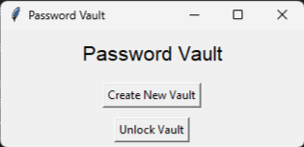

* The Main Menu

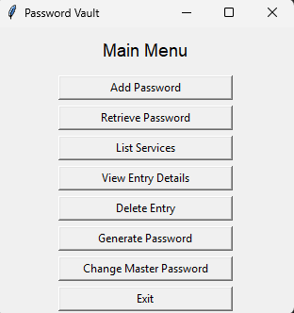

THE TESTS THAT WERE CARRIED OUT

1. The Vault Creation and Setup Test

def test_vault_setup():

    """Test vault creation and setup"""

    test_db = setup_db()

    vault = PasswordVault(test_db)

    try:

        vault.initialize_db()

        assert vault.setup_vault("test_password") is True

    finally:

        vault.close()

        if os.path.exists(test_db):

            os.remove(test_db)

1. The Vault Unlock Test

def test_vault_unlock():

    """Test unlocking the vault"""

    test_db = setup_db()

    vault = PasswordVault(test_db)

    try:

        vault.initialize_db()

        vault.setup_vault("test_password")

        assert vault.unlock_vault("test_password") is True

        assert vault.unlock_vault("wrong_password") is False

    finally:

        vault.close()

        if os.path.exists(test_db):

            os.remove(test_db)

1. The Adding and Receiving Password Test

def test_add_and_get_password():

    """Test adding and retrieving a password"""

    test_db = setup_db()

    vault = PasswordVault(test_db)

    try:

        vault.initialize_db()

        vault.setup_vault("test_password")

        vault.unlock_vault("test_password")

        assert vault.add_password("test_service", "test_user", "test_password") is True

        assert vault.get_password("test_service", "test_user") == "test_password"

        assert vault.get_password("wrong_service", "test_user") is None

    finally:

        vault.close()

        if os.path.exists(test_db):

            os.remove(test_db)

1. The Update Password Test

def test_update_password():

    """Test updating an existing password"""

    test_db = setup_db()

    vault = PasswordVault(test_db)

    try:

        vault.initialize_db()

        vault.setup_vault("test_password")

        vault.unlock_vault("test_password")

        vault.add_password("test_service", "test_user", "old_password")

        assert vault.get_password("test_service", "test_user") == "old_password"

        # Update

        assert vault.add_password("test_service", "test_user", "new_password") is True

        assert vault.get_password("test_service", "test_user") == "new_password"

    finally:

        vault.close()

        if os.path.exists(test_db):

            os.remove(test_db)

CHALLENGES ENCOUNTERED

* We found it hard choosing the appropriate libraries needed to accomplish our project’s MVP and some of the Stretch goals but we solved the problem by making research.